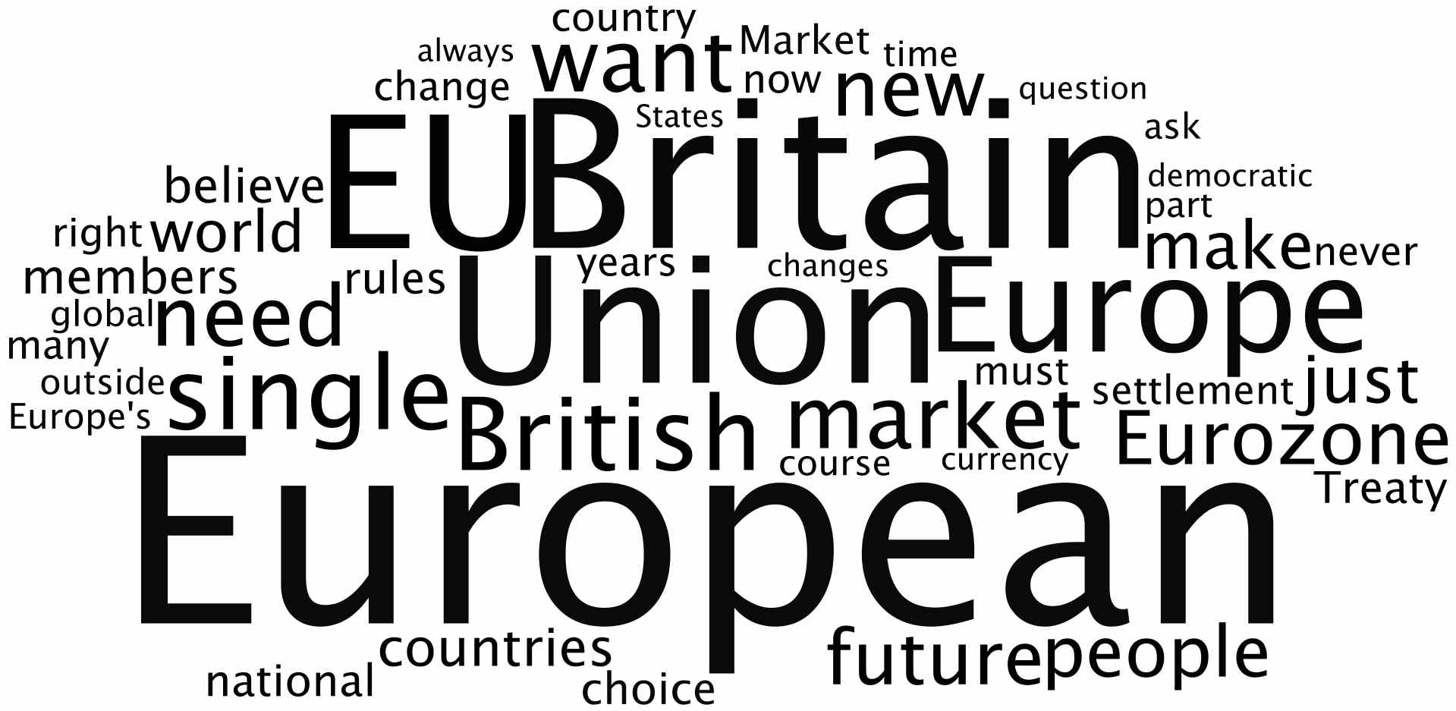
In his speech on Britain and the European Union in January 2013, the British Prime Minister used these words most frequently.

This tag cloud has been created with Wordle.

