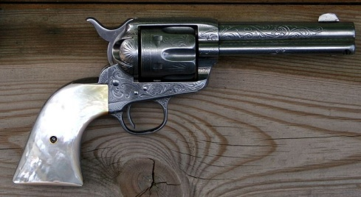
Gun-Related Incidents in “Half Broke Horses” (TASK)
Assignment
- Look up and mark these quotations in “Half Broke Horses”. – Add quotations if this list is incomplete.
- Mark those in this list with an asterisk (*) that refer back to an incident before Lily’s lifetime.
- In each case, decide which reason or purpose applies. One or two cases are ambiguous.
- Imagine having to argue for or against the use of firearms by the protagonists and list a few arguments.
Reason / purpose

Reference  Part (I - IX)  Chapter (1…) | before Lily’s lifetime | Quotations | aggression /  revenge | self-defence | hunting /  culling | protection /  deterrence | precaution
I 3 p. 20 |  | […] shootings. Dad’s pa, Robert Casey, was murdered […]
I 3 p. 20 |  | […] when a settler was killed [ …], Dad was convicted of murdering him.
I 4 p. 26 |  | […] Dad ran inside to get his guns […]
I 6 p. 30 |  | […] [Robert Casey] once had to shoot a drunk who tried to shoot him.
I 8 p. 40 |  | […] if you can’t sell [a horse], shoot him.
II 3 p. 52 |  | [Mom hated the Kid…] because he’d killed a man who was engaged to her cousin […]
II 6 p. 64 |  | […] Old Man Pucket had unapologetically admitted killing […Dad’s] Great Danes […]  [Dorothy:] You can’t go killing someone over dogs.
Reference  Part (I - IX)  Chapter (1…) |  | Quotations | aggression /  revenge | self-defence | hunting /  culling | protection /  deterrence | precaution
II 6 p. 64 f |  | [Dorothy’s…] brother had killed someone in self-defense […]  he’d been killed by that man’s cousin.
II 9 p. 75 |  | […] Dad gave me a pearl-handled six-shooter.  […] if you do have to shoot, shoot straight and be damn sure you shoot first.
III 1 p. 81 |  | I pulled [… the pearl-handled revolver] out and held it up so Priscilla could see it […]
III 3 p. 87 |  | […] a rattler […] zipped off […] before I could get out my gun.
III 10 p. 107 |  | […] I packed my pearl-handled revolver […]  […] pistol whipping [Ted Conover].
IV 5 p. 127 |  | […Jim’s father] held off the soldiers at gunpoint.
IV 5 p. 128 |  | When Jim turned eleven, his father gave him a rifle […] and said ‘Here’s your food for a week’.
V 6 p. 162 |  | […I ] pointed [… my pearl-handled revolver] at the [drunk] man’s face.
VI 4 p. 212 |  | […] I aimed just at the left of Uncle Eli’s face and pulled the trigger.
VIII 2 p. 276 |  | […] I kept my pearl-handled revolver under my bed. I also bought a little twenty-two pistol to carry in my purse. […]
VIII 4 p. 281 |  | [Lily:] ‘Who’s going to protect us from the police?’  [Principal:] ‘Just leave the gun at home.’

