Tick two options. |  |  |  |  |  |  |  | 2 marks
- According to this article, the film “Crash” is about |  |  |  | a |  |  |  | Academy Awards.
 |  |  |  | b |  |  |  | conflict between communities.
 |  |  |  | c |  |  |  | crime.
 |  |  |  | d |  |  |  | local party politics.
 |  |  |  | e |  |  |  | political correctness.
Reference:
Reference:
Tick 1 option. |  |  |  |  |  |  |  | 1 mark
- In 2006, many people were wounded as a result of inter-ethnic violence |  |  |  | a |  |  |  | behind bars.
 |  |  |  | b |  |  |  | in downtown LA.
 |  |  |  | c |  |  |  | in riots.
 |  |  |  | d |  |  |  | in schools.
Reference:
Tick two options. |  |  |  |  |  |  |  | 2 marks
- The Watts riots |  |  |  | a |  |  |  | began after the police questioned a black motorist.
 |  |  |  | b |  |  |  | broke out so that four police officers were arrested.
 |  |  |  | c |  |  |  | caused a large number of casualties.
 |  |  |  | d |  |  |  | occurred when the police questioned Rodney King.
 |  |  |  | e |  |  |  | started after a black man had been brutally beaten.
Reference:
Reference:
Tick one option. |  |  |  |  |  |  |  | 1 mark
- As for race relations, the Angelenos in the south and east of the city |  |  |  | a |  |  |  | express satisfaction.
 |  |  |  | b |  |  |  | feel worse than the others.
 |  |  |  | c |  |  |  | want immediate reform.
 |  |  |  | d |  |  |  | worry more than about anything else.
Reference:
Tick two options. |  |  |  |  |  |  |  | 2 marks
- In 2005, polls among ethnic groups about police treatment in LA showed that |  |  |  | a |  |  |  | Asians believed the most in its fairness.
 |  |  |  | b |  |  |  | Blacks felt the most that it was unfair.
 |  |  |  | c |  |  |  | Latinos felt the most unfairly treated.
 |  |  |  | d |  |  |  | Latinos were the unhappiest about it.
 |  |  |  | e |  |  |  | Whites were the happiest about it.
Reference:
Reference:
Tick two options. |  |  |  |  |  |  |  | 2 marks
- Some believe that blacks cannot easily find employment |  |  |  | a |  |  |  | although many new jobs are created.
 |  |  |  | b |  |  |  | because there is an economic downturn.
 |  |  |  | c |  |  |  | because they are discriminated against.
 |  |  |  | d |  |  |  | despite the Civil Rights Movement.
 |  |  |  | e |  |  |  | with many Mexicans immigrating.
Reference:
Reference:
Tick one option. |  |  |  |  |  |  |  | 1 mark
- In the 1992 riots |  |  |  | a |  |  |  | a black girl was shot.
 |  |  |  | b |  |  |  | Asians were badly hit.
 |  |  |  | c |  |  |  | Koreans looted most.
 |  |  |  | d |  |  |  | most of the looters were blacks.
Reference:
Tick one option. |  |  |  |  |  |  |  | 1 mark
- According to this article, “Crash” |  |  |  | a |  |  |  | reinforces ethnic stereotypes.
 |  |  |  | b |  |  |  | understates cooperation among ethnic groups.
 |  |  |  | c |  |  |  | promotes mutual respect among ethnic groups.
 |  |  |  | d |  |  |  | criticises the LA judiciary.
Reference:
Tick one option. |  |  |  |  |  |  |  | 1 mark
 |  |  |  |  |  |  |  | true |  |  |  |  | false | not in the text*
- The LA Police Department is universally respected.
Reference:
Tick one option. |  |  |  |  |  |  |  |  |  |  |  |  |  | 1 mark
 |  |  |  |  |  |  |  | true |  |  |  |  | false | not in the text*
- According to Mr Hutchinson, blacks fail to appreciate relations with Latinos.
Reference:
Tick one option. |  |  |  |  |  |  |  |  |  |  |  |  |  | 1 mark
 |  |  |  |  |  |  |  | true |  |  |  |  | false | not in the text*
- “Crash” was a box office hit in 2005.
Reference:
Tick one option. |  |  |  |  |  |  |  |  |  |  |  |  |  | 1 mark
 |  |  |  |  |  |  |  | true |  |  |  |  | false | not in the text*
- After his arrest, Rodney King called for revenge.
Reference:
Tick one option. |  |  |  |  |  |  |  |  |  |  | 1 mark
- As for the outlook for LA’s ethnic groups, the article as a whole warns against |  |  |  |  |  |  | a |  |  |  |  | civil war.
 |  |  |  |  |  |  | b |  |  |  |  | rash reforms.
 |  |  |  |  |  |  | c |  |  |  |  | self-denial.
 |  |  |  |  |  |  | d |  |  |  |  | undue pessimism.
Reference: |  |  |  |  |  |  |  |  |  |  |  | No reference needed.
www.englisch-bw.de – Lesen– “Crash“
Your name: _____________________________________________
Marks:_________/17 Grade: _________________________
The film “Crash”
and race relations in Los Angeles
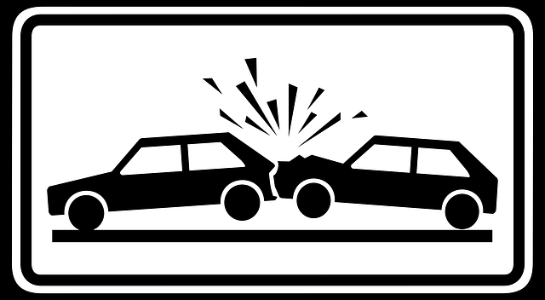
Lizenz Public Domain Bild (CC0)
Bildquelle: http://pixabay.com/de/verkehrsschild-verkehrszeichen-6771/

Reading Comprehension Test
- First read the article, then deal with the tasks.
- Tick the option that comes closest to what you understand from the text.
- Tick only the number of answers indicated in each task.
- Reference: support your choice quoting just the first and the last word of the relevant passage, from one word up to two sentences. Moreover, add lines, e.g. ll. 2-4 or line 11 onwards.
- Try out with a pencil first. Then mark clearly in ink before handing in.
Example
Tick one option. |  |  | 1 mark
- Jefferson High School is | a |  | a small school.
 | b |  | exclusively for Latinos.
 | c |  | in Beverly Hills.
 | d |  | near LA’s centre
Reference: |  |  | “just… LA” (l. 11)
www.englisch-bw.de – Lesen– “Crash“

