What you see is (not always) what you get

Be aware: This is a general still analysis – in YOUR task the focus could lie on a specific aspect!
Description:
In the given still we see Walt Kowalski ...

Content, setting:
In this film scene …

Present progressive

Simple present

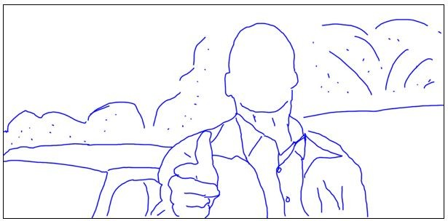
Atmosphere and overall
impression:

Cinematic devices:
camera work – size, angle, lighting, colours
dialogue
music

Analysis – assumptions on:
character
plot/ background
topic
= underlying message

Simple present

