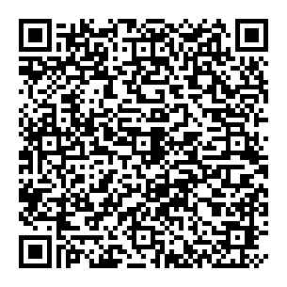
Britain and Europe:
Part 2
Use the QR code to watch the video.
Why was Britain called an "awkward member" of the EC?
Then complete this mind map.

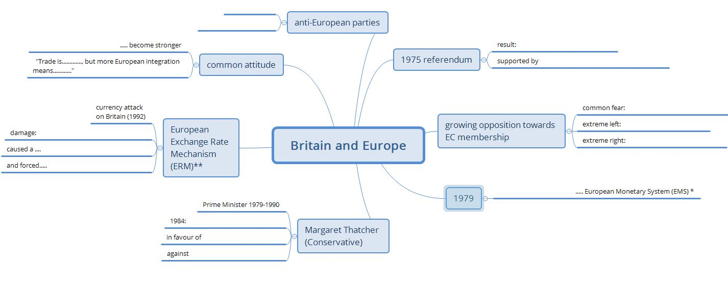
Annotations:
* European Monetary System: linking European currencies first step towards a European currency
** European Exchange Rate Mechanism: system to reduce the variability of the exchange rates of European currencies
FINISHED? AND NOW…
watch Part 3 of the series and…
complete the third mind map!

"Let's ……
"I want…

