Britain and Europe:
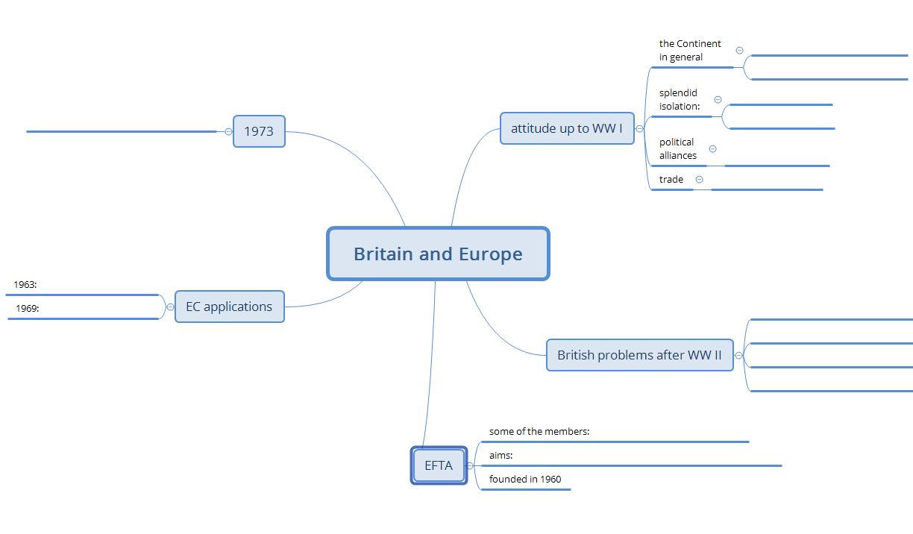
Part 1

Use the QR code to watch the video.
Then complete this mind map.
FINISHED? AND NOW…
…watch Part 2 of the series and…
…complete the second mind map!

