

Britain and Europe:
Part 3: Solutions
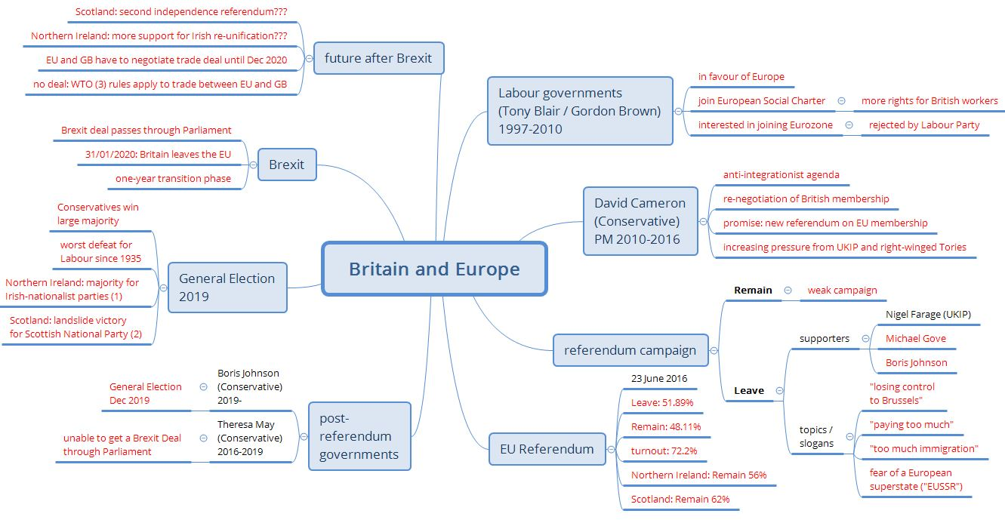
Use the QR code to watch the video.
Brexit finally happens

Annotations:
Irish-nationalist parties support the reunification of Northern Ireland and the Republic of Ireland
The Scottish National Party (SNP) supports Scottish independence from Great Britain
WTO: World Trade Organisation

