The position of adverbs – Exercises II
Adverbs of manner
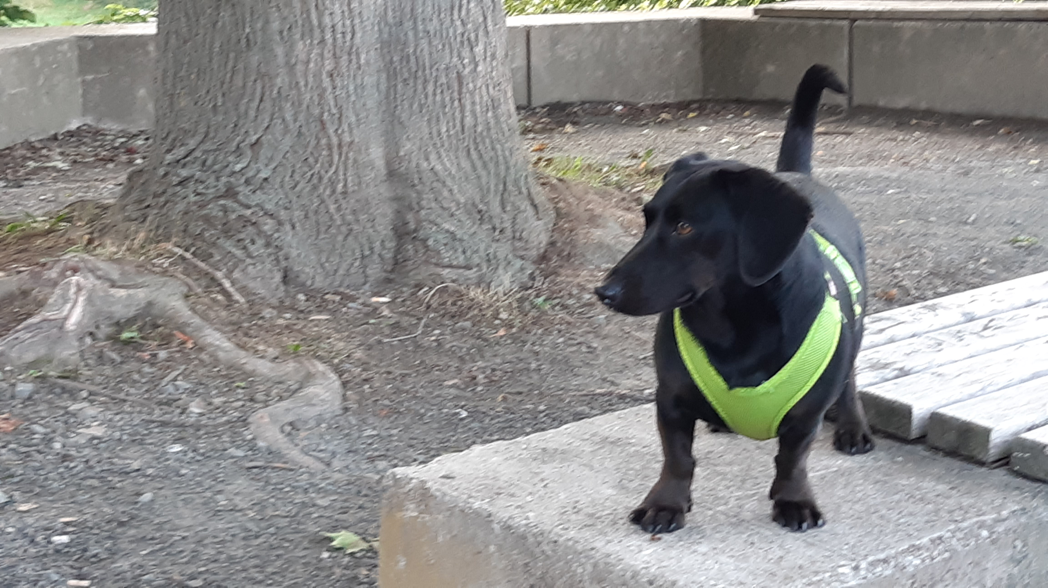
Remember:
Adverbs of manner stand
AFTER full verbs (and their objects).

Change the adjectives in brackets to adverbs and decide for their correct places.
What does Mr. Goodwill do when he is not at school?

- To school and back home Mr. Goodwill rides his bike. He can …................................. ride extremely …................................. (good). He never …......................................... rides …......................................... (dangerous). Even in bad weather, he rides …......................................... his bike …...................................... (joyful) – maybe because he has a funny raincoat and all the people who see him smile …................................. (friendly  )?
- In the afternoons and evenings, he thinks of the next school day. Then he prepares …......................................... the lessons and tests for his students …..................................... (careful).
- In his free time Mr. Goodwill likes music very much. He does not only listen to music …................................. (silent), but he also sings …................................. along …................................. (loud). And he can also play some instruments. For example, he can …......................................... play the bagpipes ….......................... (good) and he can …......................................... even play the piano …................................. (fabulous).
- Mr. Goodwill sometimes likes to play tennis with another teacher. But he does not …......................................... play very …..................................... (masterful).

- Unfortunately, he cannot dance …................................... (brilliant). He thinks that his neighbour Mrs. Merrygold likes to go dancing. This is why he looks …................................. at the dancers in the park ….............................. (curious). He hopes that one day he can copy some steps with Mrs. Merrygold …............................... (easy).
- Of course, Mr. Goodwill likes football. He claps and cheers ….............................. (happy) when his football team wins. And he almost cries …...........................(sad) when his team plays …........................... (bad).
- The best time of the day, however, is when Mr. Goodwill and Winston go out together: This is so much fun and both of them enjoy …...................................... their time together ….............................. (enormous).

unfortunately: leider
however: jedoch

