The position of adverbs – Exercises III
Adverbs of place and time
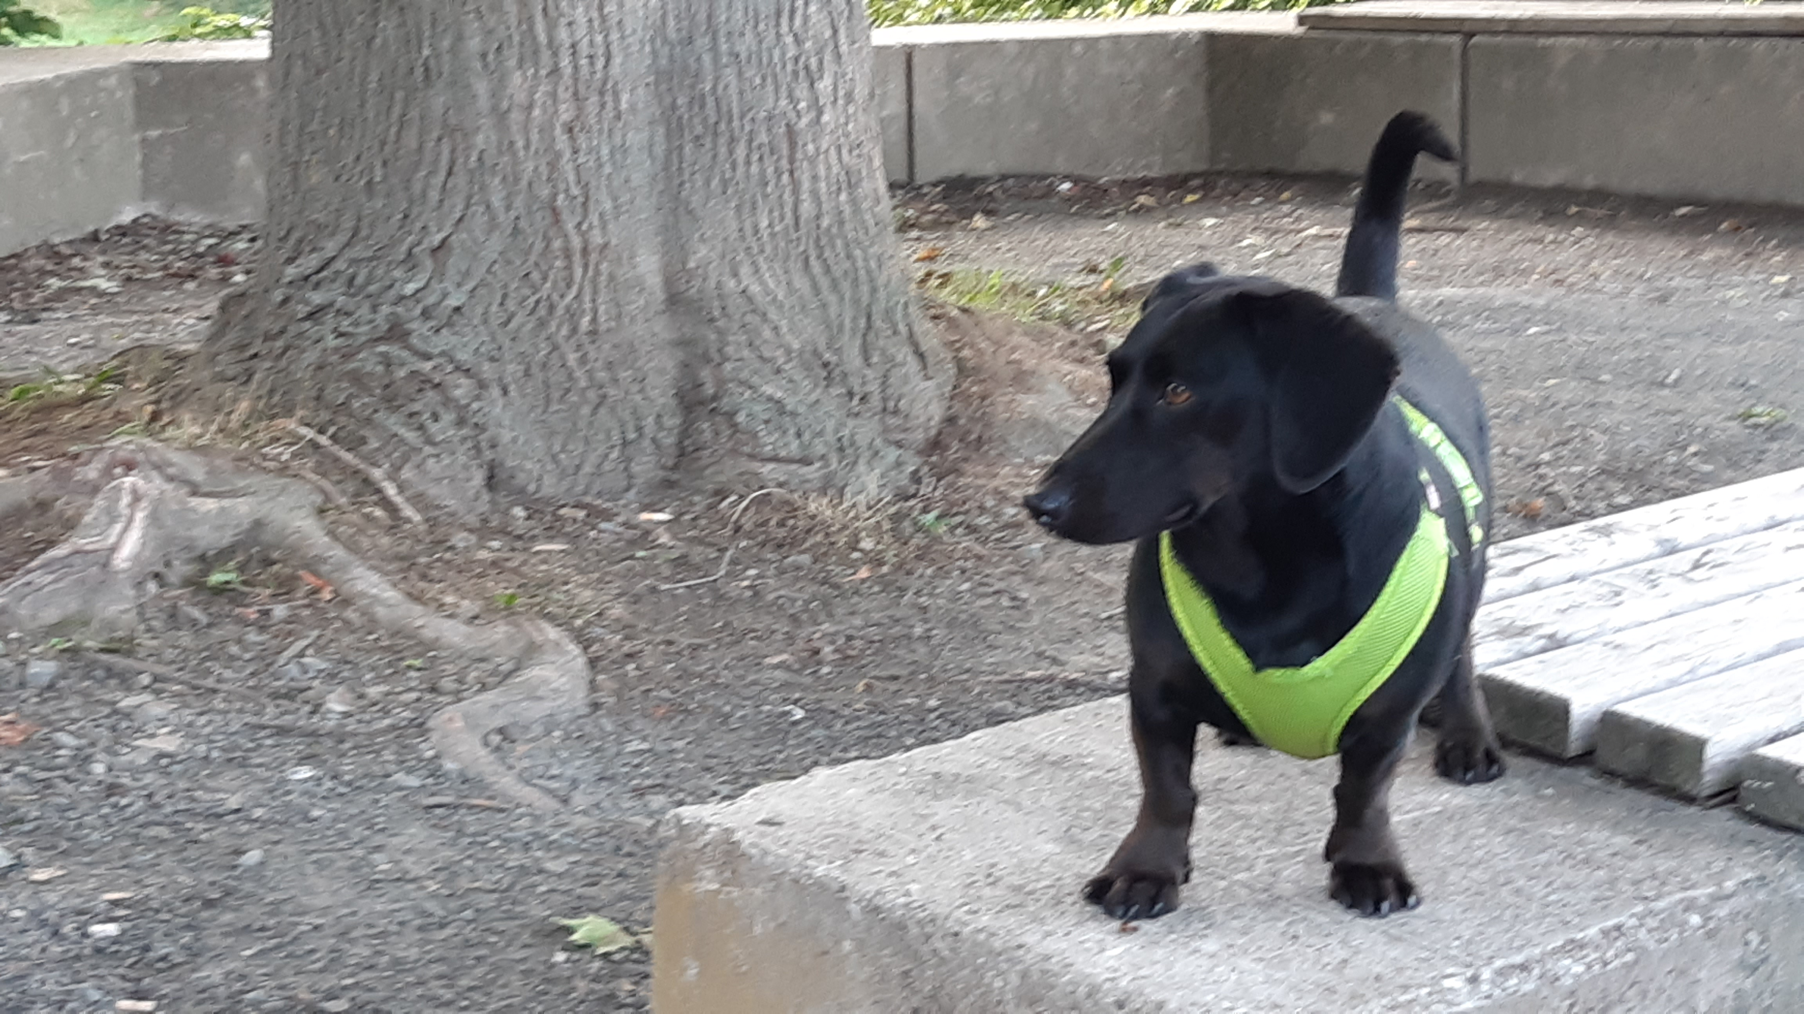
Remember:
PLACE before TIME.

Fill in the adverbs (appearance in brackets: in alphabetical order).

A party!
Last Saturday was a special Saturday for Mr. Goodwill and Winston, because they were invited to a party. Their neighbour Mrs. Merrygold has a weekend cottage with a big garden. She often goes …...….......................................................................... (on Saturdays and Sundays; there), because it is a wonderful place. She knew that the weather would be good and so she invited some friends and neighbours ….......................…...…............................................................................................................ (for Saturday at 8 pm; to her cottage).

As the place lies outside town, Mr. Goodwill had to take Winston to the party by train. Before they could go to the party, however, they needed a small present for the hostess. Winston wondered what to bring and thought about a big sausage for Mrs. Merrygold! “Oh no, it's flowers which are always great for a woman, my dear Winston,” said Mr. Goodwill and so the two went …........................................…...….......................................................................... (in the afternoon; to a flower shop).

With the flowers and a blanket against the cold the two set off ….........................................................................................…...…............. (at 7 o'clock; for the train station). The trip did not take long and they arrived ….......................…...…...................................................................................................... (at the right station; at quarter past seven).
After a short walk, which Mr. Goodwill and Winston enjoyed very much, they came ….......................…...…................................................................................................ (at half past seven; to the pretty cottage). Mr. Goodwill wanted to help Mrs. Merrygold ….......................…...….................................................................................... (before the other guests arrived; in the kitchen) – and Winston knew that he also wanted to spend some time alone with her! But this is another story...

When the guests came, Mrs. Merrygold served cold drinks ….................................…...…........................................................................................ (at around 8 o'clock; in front of the cottage). As Winston was a special guest, he did not only get a bowl of fresh water but also a sausage. Well, that was a start for a party!

Later they all had a picnic ….......................…...…................................................... (in the grass; this evening). The guests ate snacks in glasses such as chicken salad, potatoes with dressing and fruit for dessert. For Winston Mrs. Merrygold had a sausage pie. What a feast! Afterwards the guests talked about this and that while they sat ….......................…...…................................................................... (in chairs; until it became dark). For Winston this was a wonderful time, too: There were many hands which wanted to pet him.

Then Mrs. Merrygold surprised everyone: She had fireworks ….......................................…...…..................................................... (at midnight; at the back of the cottage). First, Winston was a bit afraid of the fireworks' “bang”, “boom” and “whoosh”, which could be heard ….................................................................................…...…................ (all over the place; around midnight).
But Mr. Goodwill held him ….......................................................................................... (close to his body; for the whole time of the fireworks) and as nothing bad happened he quickly calmed down. In the end, he enjoyed the fireworks' colours very much!

How Winston got ….............................................................. (after the fireworks; home), he did not really know – so many sausages and impressions... What a night!

host, hostess: Gastgeber, Gastgeberin
What a feast: Welch ein Festmahl/ Schmaus
impressions: Eindrücke

