Grammar / The simple present / exercises / answer key
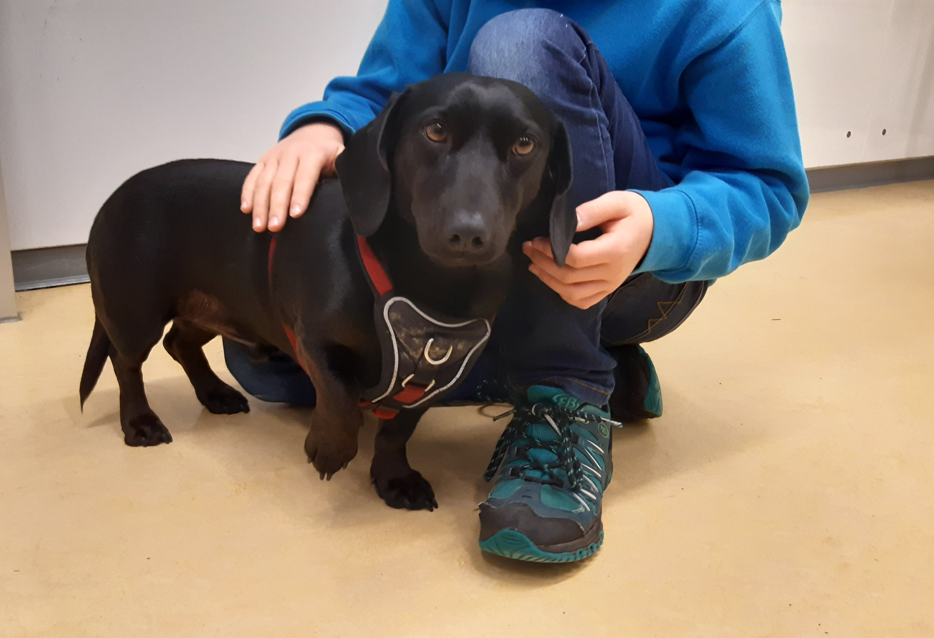
- What dogs do and don’t do
- Are these sentences right or wrong ?
- Correct the wrong statements
(= verbessere die falschen Sätze.)
- Dogs eat pizza for breakfast.
Dogs don’t eat pizza for breakfast, they eat dog food.

- Dogs like long walks in the park.
- Dogs play computer games.
Dogs don’t play computer games, they play with toys.
- Winston works at a school.
- Winston teaches English to his students.
Winston doesn’t teach English, he helps his students (to concentrate).

- Winston always barks at his students.
Dogs doesn’t bark at his students, he likes them.

He, she, it,
das -s muss mit!

- A day in the life of a school dog
- Please fill the gaps with the correct forms of the verb
– use the simple present!
Winston is a school dog. He works (to work) at a big school. He doesn’t teach (not + to teach) the students, but he helps (to help) them a lot. His friend, Mr Goodwill, is (to be) a teacher and Winston helps (to help) him, too. He wakes (to wake) him up every morning and he barks (to bark) at him when he is (to be) late – not late for school, but late for his breakfast.
“I need (to need) a good breakfast before school starts (to start). I like (to like) dog food and a bit of fruit for breakfast, but I don’t like (not + to like) muesli. I don’t know (not + to know) why Mr Goodwill likes (to like) muesli. That is food for birds. Oh well, he is (to be) a Music teacher, too. Maybe he eats (to eat) muesli to sing like a bird – woof woof!?
We both like (to like) cheese a lot, but I don’t get (not + to get) cheese very often. Luckily I know (to know) where the cheese is and when Mr Goodwill does (to do) his homework, I do (to do) my work, too … I help (to help ) in the kitchen - I clean (to clean) the fridge and eat (to eat) all the smelly cheese. I like (to like) a clean kitchen ”.

(to) teach = unterrichten / beibringen
luckily = glücklicherweise
fridge = Kühlschrank

