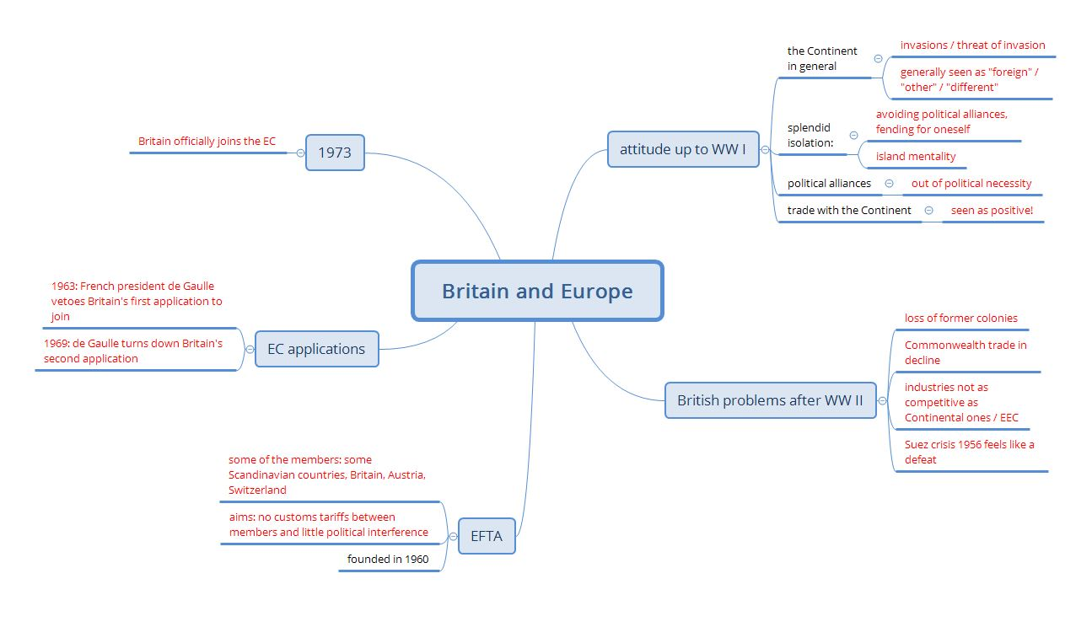Britain and Europe:



*Find the video here.*

Part 1 -- Solutions

**FINISHED? AND NOW…**

**🗹 …watch Part 2 of the series and…**

**🗹 …complete the second mind map!**