Britain and Europe:
Part 3
Use the QR code to watch the video.
Brexit finally happens
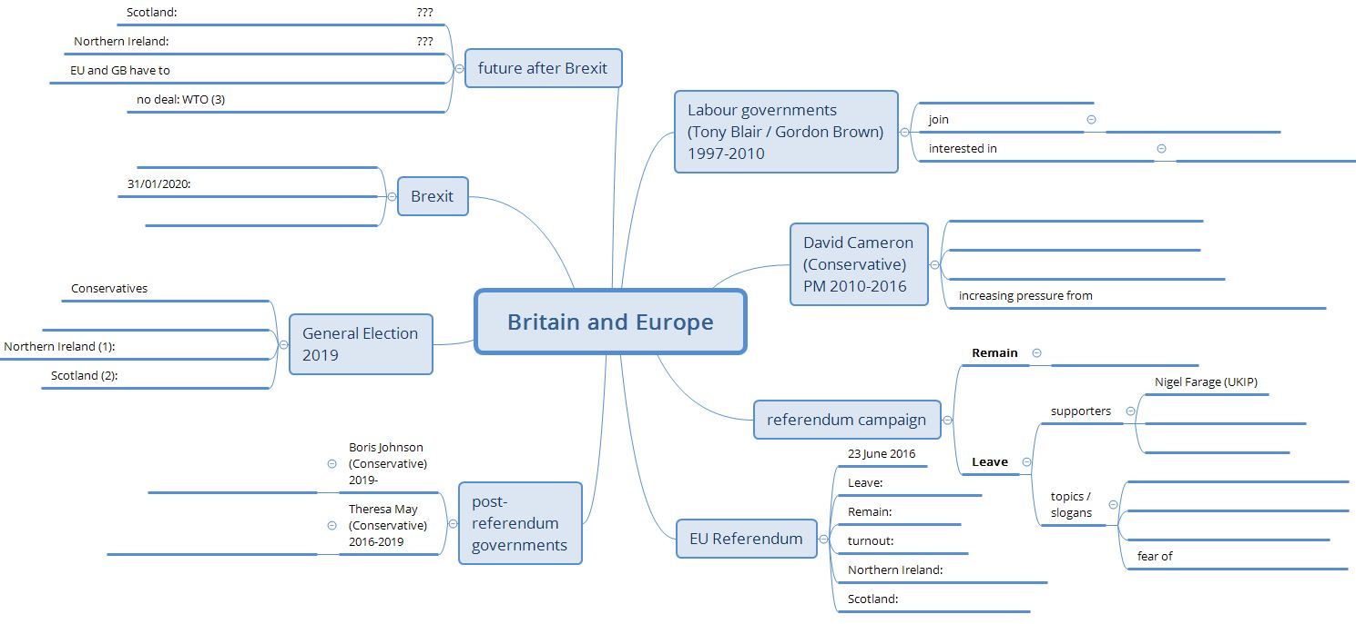
Then complete this mind map.

Annotations:
- Irish-nationalist parties support the reunification of Northern Ireland and the Republic of Ireland
- The Scottish National Party (SNP) supports Scottish independence from Great Britain
- WTO: World Trade Organisation

