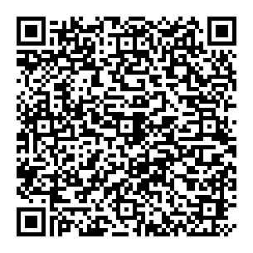
Britain and Europe:
Part 2: Solutions
Use the QR code to watch the video.
Why was Britain called an "awkward member" of the EC?
"Let's get out of Europe!"
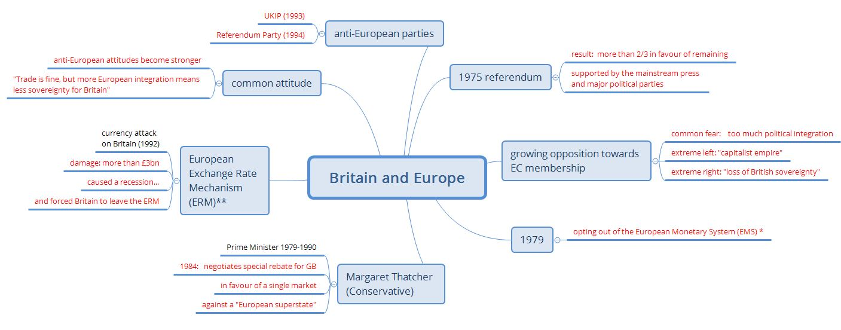
Annotations:
* European Monetary System: linking European currencies first step towards a European currency
** European Exchange Rate Mechanism: system to reduce the variability of the exchange rates of European currencies
"I want my money back!"

