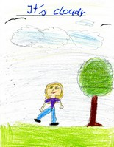
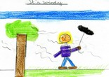
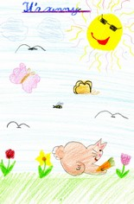

Word search “Weather“ (1)

D | V | G | Z | B | M | C | B | I | P | E | W | F | Z
Q | A | Y | D | C | O | L | D | H | K | L | R | O | V
A | Y | S | W | G | T | O | J | K | P | K | E | G | S
E | C | H | L | T | S | U | N | N | Y | K | P | G | W
F | F | O | D | F | E | D | T | N | B | V | R | Y | L
W | S | T | O | R | M | Y | G | R | E | S | A | N | B
B | U | D | X | E | W | K | S | N | O | W | I | N | G
O | F | O | W | E | R | T | P | L | T | S | N | E | W
C | V | I | O | Z | R | N | W | I | N | D | Y | L | R
W | E | C | G | I | H | J | A | Y | C | R | Z | K | B
V | T | H | U | N | D | E | R | S | T | O | R | M | L
U | E | D | G | G | H | O | M | W | V | K | N | T | V

Can you find these words?

rainy, windy, cloudy, sunny, thunderstorm, snowing, hot, warm, cold, freezing, foggy, stormy
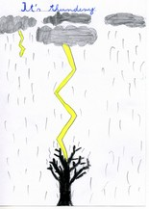
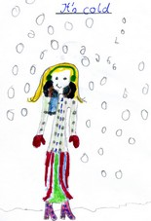
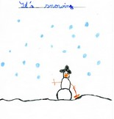

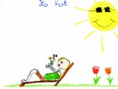
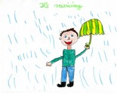
Word search “Weather“ (2)

D | V | G | Z | B | M | C | B | I | P | E | W | F | Z
Q | A | Y | D | C | O | L | D | H | K | L | R | O | V
A | Y | S | W | G | T | O | J | K | P | K | E | G | S
E | C | H | L | T | S | U | N | N | Y | K | P | G | W
F | F | O | D | F | E | D | T | N | B | V | R | Y | L
W | S | T | O | R | M | Y | G | R | E | S | A | N | B
B | U | D | X | E | W | K | S | N | O | W | I | N | G
O | F | O | W | E | R | T | P | L | T | S | N | E | W
C | V | I | O | Z | R | N | W | I | N | D | Y | L | R
W | E | C | G | I | H | J | A | Y | C | R | Z | K | B
V | T | H | U | N | D | E | R | S | T | O | R | M | L
U | E | D | G | G | H | O | M | W | V | K | N | T | V

Write down the weather words you find:

____________________ ____________________
____________________ ____________________
____________________ ____________________
____________________ ____________________
____________________ ____________________
____________________ ____________________

Lösung - solution

 |  |  |  |  |  | C |  |  |  |  |  | F
 |  |  |  | C | O | L | D |  |  |  |  | O
 |  |  |  |  |  | O |  |  |  |  |  | G
 |  | H |  |  | S | U | N | N | Y |  |  | G
 |  | O |  | F |  | D |  |  |  |  | R | Y
 | S | T | O | R | M | Y |  |  |  |  | A
 |  |  |  | E |  |  | S | N | O | W | I | N | G
 |  |  |  | E |  |  |  |  |  |  | N
 |  |  |  | Z |  |  | W | I | N | D | Y
 |  |  |  | I |  |  | A
 | T | H | U | N | D | E | R | S | T | O | R | M
 |  |  |  | G |  |  | M

