Health and Wellness

1. Stunde: Mindmap zum Thema Gesundheit und Wellness (Deutsch)
2. Stunde: Definitionen zum Thema Wellness (Englisch)
3. Stunde: The Life Span (Englisch)
4. Stunde: Internet-Quiz “The Longevity game“ (Englisch)
5. Stunde: Video Massage: Anschauen und Ausprobieren (Englisch)
6. Stunde: Wellnessberufe (Englisch)
Kommentar:
Die jeweils richtigen Lösungen in den folgenden Arbeitsblättern sind rot dargestellt.

Weiterführende Arbeit (Deutsch)
- Welche Betriebe gibt es in unserer Nähe, die sich mit Wellness beschäftigen?
- Besuch eines Betriebs
- Planung eines Wellnessnachmittags für jüngere Schüler

What’s Wellness?

If you are not ill and your body works perfectly, then you are healthy. Wellness means more than that. There are different dimensions of wellness. Here are some examples:

- Physical Wellness | - Emotional Wellness
- Intellectual Wellness | - Spiritual Wellness
- Social Wellness | - Mental Wellness

- What dimension of Wellness are they talking about? Write down the numbers.
I love may family. I have lots of friends. I enjoy spending time with friends and family.
I don’t need alcohol or drugs to be happy. I have some other ideas what to do when I’m feeling down.

I do sports three times a week.
I see the doctor and the dentist regularly for check-ups.

I care about the needs of others.

I eat fruits, vegetables, and whole grain products every day.

Prayer or meditation is important for my life.
I have a great job. I look forward to work.

I carefully select movies and television programs.

I get along with many people well. Most people like me.

- When you have finished compare your ideas with a partner.
- Talk about your answers in class.

The Life Span

When you were born in 1900 you could expect for 50 years. Now you can expect to live for 80 years. Here are some reasons. Draw pictures or symbols.

In 1900 …
… many babies died before they were six years old. | … there was no cure for many deseases. | … people could not get a large variety of food. | … many people suffered from the consequences of war.

Here are some factors that have an impact on how long a person is going to live. Read the sentences and mark them with + or -.
+ This might prolong your life. - This might shorten your life.

+ | You are female.
+ | You do sports three times a week.
- | You don’t know your blood pressure.
- | You drink alcohol every day.
- | You eat fast food more than three times a week.
- | You get angry easily.
+ | You have a close friends to talk to.
+ | You have never smoked.
+ | You see a doctor regularly
- | You smoke a pack of cigarettes a day.
+ | You wear a helmet when you ride your bike.
- | Your Body Mass Index is greater than 30.
- | Your grandparents suffered from a heartattack or stroke before 65.
- | Your systolic blood pressure is greater than 140.

Check for yourself and make a TEST:
http://www.northwesternmutual.com/learning-center/the-longevity-game.aspx

How to give a massage

http://www.wikihow.com/Give-a-Relaxing-Massage-in-School

Watch the video and mark the words that you hear:

back of the neck lungs legs forearms eyes
ears muscles neck nose
shoulder spine thumbs toes

What are these parts of the body in English?

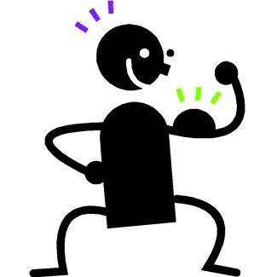 |  | 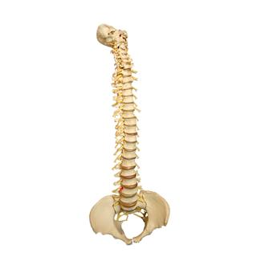 | 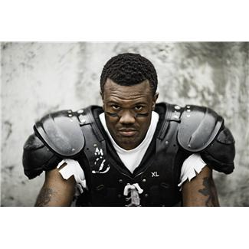
muscles | thumb | spine | shoulder

The massage is against pain in the head ________________ and the ________________ neck.

What is she doing? Put into the right order.

1 | Ask your partner to take a deep breathe.
8 | Ask your partner to take a deep breathe.
6 | Lean with your forearms on your partners shoulders and work into the muscles.
4 | Place your thumbs between the neck and the spine and bring pressure into your thumbs.
3 | Squeeze up the back of the neck. There is much tension stored from driving, computer work…
7 | Squeeze up the shoulder.
5 | Stroke out from the neck to the shoulders.
2 | Touch the person and start squeezing the muscles between the shoulder and the neck.

Watch the video again and do the massage with your partner.

How did you feel?

Wellness Jobs

1. What wellness jobs do you know?
2. Read the job descriptions and match them with the jobs.

beautician |  | He or she takes care of your feet.
dental assistant |  | This person is an expert for beauty. He or she takes care of your skin.
dietary adviser |  | This person knows how to give a massage.
hairdresser |  | He or she shows you gymnastic exercises which help you to recover.
massage therapist |  | This person does your hair.
physiotherapist |  | He or she tells you what is good to eat and helps you to lose weight.
podiatrist |  | This person helps the dentist.

3. What do you think about these jobs?
My favourite wellness job is _________________________________, because
________________________________________________________________

I am not very interested in working as a __________________________, because
________________________________________________________________

4. What wellness jobs are there in your town?

________________________________________________________________
________________________________________________________________
________________________________________________________________

