KEY
Download the audio file from “What Happened to the European Dream” at “The Inquiry”
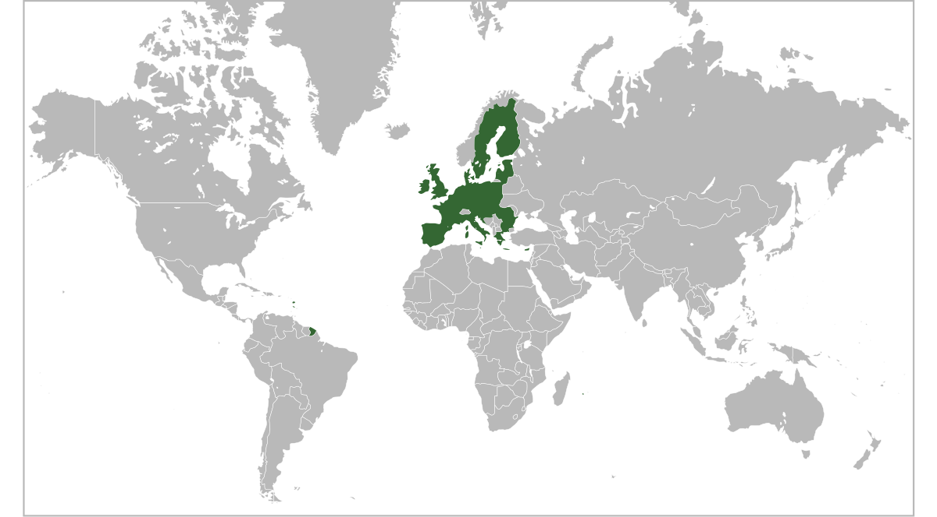
Outline of the European Union by Ssolbergj, licensed under Attribution 3.0 International (CC BY 3.0),

What happened to the European Dream?

Listening Comprehension Exercise
Read the questions. Then listen to the recording. There will be a brief break. Then listen again and check and/or complete your answers.
Examples:
Tick the correct answer. (1 credit)
- The referendum is about: should the United Kingdom | a | □ | dismember the European Union or become a member?
 | b |  | remain in the European Union or leave the European Union?
 | c | □ | resist membership of the European Union or join the European Union?
 | d | □ | stay in the European Union or leave the European Union?

True or false? (1 credit) | true | false
- In several member countries anti-EU parties are getting more popular. |  | □
Download this exercise and key from
www.englisch-bw.de – Hörverstehen – What has become of the European Dream?

Tick the correct answer. (1 credit)
- The president of the EU commission | a | □ | claimed that the EU had never been more attractive.
 | b | □ | denied that the EU was unpopular.
 | c | □ | said that the EU was as attractive as before.
 | d |  | stated that the EU had lost some of its appeal.
Part I – a continent rebuilt (1950s) (~1.30)
True or false? (1 credit each) | true | false
- Right after World War II Europe faced enormous challenges. |  | □
- The so-called Founding Fathers started to redraw European borders. | □ | 
- Jean Monnet lost his seat in the French parliament in the late 1920s. | □ | 
- During WWII Robert Schuman opposed the German occupation of France. |  | □
Tick the correct answer. (1 credit)
- People like Schuman and Monnet wanted European states to | a | □ | compete with each other for economic supremacy.
 | b | □ | join NATO and support the US in Korea.
 | c |  | live in peace and cooperate economically.
 | d | □ | unite and fight the Soviet Union.
True or false? (1 credit each) |  |  |  | true | false
- Just after WWII Germany had most of Europe’s steel. |  |  |  | □ | 
- The policy was taking away what Germany had. |  |  |  | □ | 
Tick the correct answer. (1 credit)
- The European Coal and Steel Community made national governments | a | □ | cooperate to keep Germany from rebuilding its industries.
 | b |  | give it the power to distribute coal and steel resources.
 | c | □ | give up steel and coal allocation to the US administration.
 | d | □ | follow recommendations from the EU commission.

- Briefly complete this sentence in your own words. (2 credits)
The fundamental idea was that economic cooperation…
would also encourage political cooperation.

Part II – the golden age (1960s – 90s) (~6.40)
Tick the correct answer. (1 credit)
- The European Economic Community of the 1960s and 1970s was about | a |  | establishing a free trade area for its members.
 | b | □ | keeping countries such as Ireland and Denmark out.
 | c | □ | progress toward political integration in Europe.
 | d | □ | preventing any of political integration.
Tick the correct answer. (1 credit)
- In the 1980s Jacques Delors wanted | a | □ | a pan-European government to replace national governments.
 | b |  | to integrate member states economically as well as politically.
 | c | □ | the French Franc to become the Community’s common currency.
 | d | □ | western Europe to turn socialist.

True or false? (1 credit) | true | false
- Establishing a common currency requires common rules on taxing and spending. | □ | □

Tick the correct answer. (1 credit)
- The Maastricht Treaty in the early 1990s meant | a | □ | renaming the “European Economic Community” to “EU Market”.
 | b | □ | European countries increasing their defence budgets.
 | c |  | more political integration among member states.
 | d | □ | empowering the European parliament.
Part III – overreach? (since the 1990s) (~11.40)
True or false? (1 credit each) | true | false
- People feeling at home in several European countries liked the European dream. |  | □
- Jacques Delors wanted most laws in Europe made in Brussels. |  | □
- The idea of a common European currency made integration popular. | □ | 
- People began to worry about the loss of national sovereignty. |  | □
- In 2005 the European constitution was approved in France by a narrow majority. | □ | 

Tick the correct answer. (1 credit)
- The crises Europe has experienced since 2005 suggest that | a | □ | a united Europe is a danger to global stability.
 | b |  | Europe has either integrated too much or too little.
 | c | □ | only national governments can solve national problems.
 | d | □ | too much European integration is their root cause.
Part IV – where to now? (2005 – today) (~17.00)
Tick the correct answer. (1 credit)
- According to Nikolaus Blome, deputy editor of „Bild“, the EU is in poor shape because of e.g. | a | □ | a renaissance of the euro.
 | b | □ | trade barriers.
 | c | □ | interest rates.
 | d |  | refugees and nationalism.

True or false? (1 credit each) | true | false
- Today, European integration does not excite people. |  | □
- Easy goals like preventing war have been accomplished. |  | □
- Issues like domestic security, taxes and defence have been settled. | □ | 
- The British referendum about EU membership shows popular disenchantment. |  | □
Tick the correct answer. (1 credit)
- According to Blome, with | a | □ | Brexit countries such as Ireland might try to leave the EU.
 | b |  | Brexit, some member states might try further integration.
 | c | □ | Britain remaining, the EU will accept new members.
 | d | □ | Britain remaining, integration would stop.

- Briefly complete this sentence in your own words. (3 credits)

According to Blome, Europe needs to achieve practical goals such as…
solving the refugee crisis / economic growth
and… settling Greece[’s debt crisis]
and… a consolidated EU [ready for a new start]

