Technical Terms Redemittel Filmanalyse
A Field size, camera angle – Classify each shot and give each a suitable heading.
B Frame – Add information here that you see in comics, e.g. “Suddenly, in the garden...”
C Action – Briefly describe what is going on in the present progressive,
e. g. “a man in a masque is raising his hand and...”
I love you.
D Dialogue or thought – Fill in speeches or thoughts.
E Camera | Effect on Viewers
Field Size | 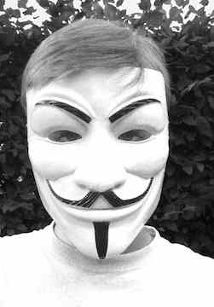 |  | 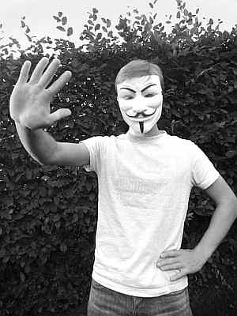 |  | 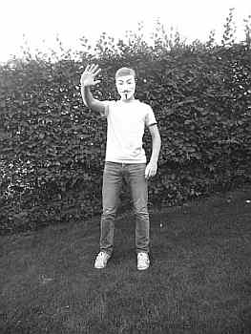 |  | 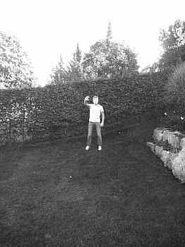
 | close-up: facial expression or some other detail |  | half shot: from hip to head |  | medium shot: from head to toe, focus on (inter-) action |  | long shot: A human figure seen from a distance
Zoom |  | from a close-up zooming out to a long shot  from a long shot, zooming in to a close-up
Camera  Movements | panning left and right  showing where things are, e.g. furniture in a room |  |  | tilting up or down  vertical movement, e.g. tracking things falling down |  | a static shot  shows what characters are doing, what they look like
Camera  Angles | 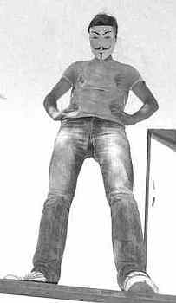 |  |  | 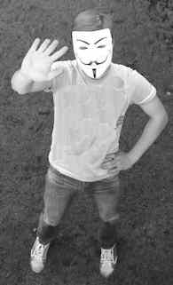 |  | 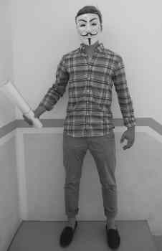
 | low angle – shot from below  effect on the viewer: it makes things/people look big and it makes viewers feel small |  |  | high angle – shot from above  effect on the viewer: it makes things/people look small and it makes viewers feel powerful. |  | eye-level angle – shot from the same level:  effect on the viewer: it makes people look the same height, suggesting equal status
Cut | A cut is where one shot ends and another begins, for example:  1) Level half shot: a character is taking out his wallet.  2) Cut to high angle close up shot: money is being counted.  2) Cut to level medium shot: a door is opening.  3) Cross cut back to level close-up shot: someone is looking over his shoulder.  This means: A film director puts shots together in the montage [‘--] so that viewers see the whole of the film as one continuous story that they may retell thus: When Mr X was counting stolen money in his room, suddenly the door opened and Mr X wondered who it was.

