The position of adverbs – Answer Key
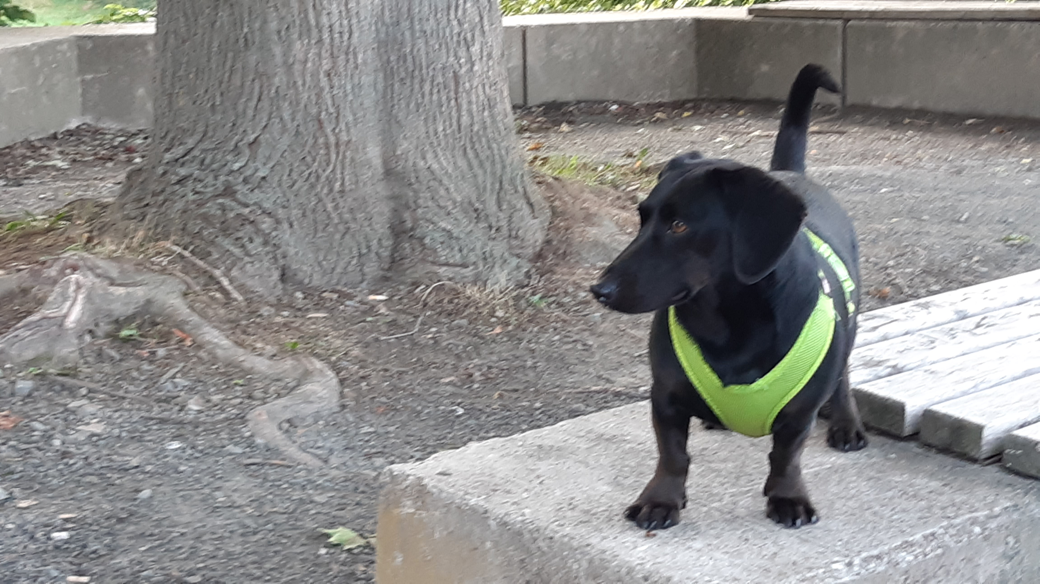
- Adverbs of frequency
Remember:
Adverbs of frequency (one word) usually stand BEFORE the full verb
but AFTER a form of to be.
If the adverbs consist of more than one word
you put them at the BEGINNING or at the END of the sentence.

Fill in the adverbs. More than one position can be correct.
Mr. Goodwill and Winston, the sausage dog
Mr. Goodwill and his dog Winston live together in a terraced house. They are very good friends and like to be together. So neither Mr. Goodwill nor Winston is ever lonely. They almost always spend their time together: First, on certain weekdays they go to school together on certain weekdays. Secondly, they are together at their house, in their garden or go for long walks together.

From Monday to Friday Mr. Goodwill and Winston go to school together from Monday to Friday. When they are at school, Winston usually helps Mr. Goodwill. But on Wednesdays Winston never comes to school with Mr. Goodwill on Wednesdays, because on Wednesdays he goes to dog school on Wednesdays.
It is always Mrs. Ironlady who takes Winston and her dog Maggie there. This year the two dogs are together in form 3 this year. There Winston usually learns new tricks he absolutely loves. These tricks can be difficult, so he sometimes gets homework. He always does this homework after lunch break. Then he normally plays with a ball in the garden. He also sometimes does some extra exercises he learns at his dog's school.

In the evenings Mr. Goodwill sometimes goes out in the evenings. He usually goes to the pub and meets a friend. Every Friday he goes to his favourite pub 'Ye Olde Cheese” every Friday. There he always takes part in the famous pub quiz. Good for Winston: Mr. Goodwill is not often home late. But when he arrives home, Winston always comes to Mr. Goodwill and sniffles curiously. And then both of them are very happy to be together again!

- Adverbs of manner
Remember:
Adverbs of manner stand
AFTER full verbs (and their objects).

Change the adjectives to adverbs and decide for their correct places.

What does Mr. Goodwill do when he is not at school?
- To school and back home Mr. Goodwill rides by bike. He can ride extremely well. He never rides dangerously. Even in bad weather, he rides his bike joyfully – maybe because he has a funny raincoat and all the people who see him smile in a friendly way?
- In the afternoons and evenings, he thinks of the next school day. Then he prepares the lessons and tests for his students carefully.
- In his free time Mr. Goodwill likes music very much. He does not only listen to music silently, but he also sings along loudly. And he can also play some instruments. For example, he can play the bagpipes well and he can even play the piano fabulously.
- Mr. Goodwill sometimes likes to play tennis with another teacher. But he does not play very masterfully.
- Unfortunately, he cannot dance brilliantly. He thinks that his neighbour Mrs. Merrygold likes to go dancing. This is why he looks at the dancers in the park curiously. He hopes that one day he can copy some steps with Mrs. Merrygold easily.
- Of course, Mr. Goodwill likes football. He claps and cheers happily when his football team wins. And he almost cries sadly when his team plays badly.
- The best time of the day, however, is when Mr. Goodwill and Winston go out together: This is so much fun and both of them enjoy their time together enormously.

- Adverbs of place and time
Remember:
PLACE before TIME.

Fill in the adverbs.

place
time

A party!
Last Saturday was a special Saturday for Mr. Goodwill and Winston, because they were invited to a party. Their neighbour Mrs. Merrygold has a weekend cottage with a big garden. She often goes there on Saturdays and Sundays, because it is a wonderful place. She knew that the weather would be good and so she invited some friends and neighbours to her cottage for Saturday at 8 pm.
As the place lies outside town, Mr. Goodwill had to take Winston to the party by train. Before they could go to the party, however, they needed a small present for the hostess. Winston wondered what to bring and thought about a big sausage for Mrs. Merrygold. “Oh no, it's flowers which are always great for a woman, my dear Winston,” said Mr. Goodwill and so the two went to a flower shop in the afternoon.
With the flowers and a blanket against the cold the two set off for the train station at 7 o'clock. The trip did not take long and they arrived at the right station at quarter past seven. After a short walk, which Mr. Goodwill and Winston enjoyed very much, they came to the pretty cottage at half past seven. Mr. Goodwill wanted to help Mrs. Merrygold in the kitchen before the other guests arrived – and Winston knew that he also wanted to spend some time alone with her! But this is another story...

When the guests came, Mrs. Merrygold served cold drinks in front of the cottage at around 8 o'clock. As Winston was a special guest, he did not only get a bowl of fresh water but also a sausage. Well, that was a start for a party!
Later they all had a picnic in the grass this evening. The guests ate snacks in glasses such as chicken salad, potatoes with dressing and fruit for dessert. For Winston Mrs. Merrygold had a sausage pie. What a feast! Afterwards the guests talked about this and that while they sat in chairs until it became dark. For Winston this was a wonderful time, too: There were many hands which wanted to pet him.
Then Mrs. Merrygold surprised everyone: She had fireworks at the back of the cottage at midnight. First, Winston was a bit afraid of the fireworks' “bang”, “boom” and “whoosh”, which could be heard all over the place around midnight.
But Mr. Goodwill held him close to his body for the whole time of the fireworks and as nothing bad happened he quickly calmed down. In the end, he enjoyed the fireworks' colours very much!
How Winston got home after the fireworks, he did not really know – so many sausages and impressions... What a night!

- Adverbs of frequency, of manner and adverbs of place and time
Remember:
MANNER before PLACE before TIME.

Fill in the adverbs.

frequency
manner
place
time

Winston and Mr. Goodwill on the way to school
- Before Mr. Goodwill goes to school in the mornings, Winston is often at the front door. He likes the students and waits for the lessons eagerly.

- Mr. Goodwill's bag usually lies at the door from Monday to Friday. He always packs his school bag carefully. He usually does that job on Sunday evening, so everything is prepared for the school day.

- When they are ready, Winston follows Mr. Goodwill happily to the bike shed, because Mr. Goodwill rides by bike to school every week day.

- Winston always comes along but for Wednesdays, when he is at dog school from 9 to 11 am.

- Winston can follow Mr. Goodwill easily to school, because he can run quickly. They both enjoy their ride because of the fresh air, which makes them ready for the day. And so the day can start!

on certain weekdays: an bestimmten Werktagen
unfortunately: leider
however: jedoch
host, hostess: Gastgeber, Gastgeberin
What a feast: Welch ein Festmahl/ Schmaus
impressions: Eindrücke
bike shed: Fahrradschuppen

