CAPRI  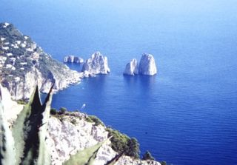 | ISOLA BELLA  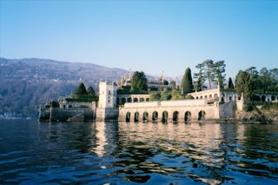
ISOLE TREMITI  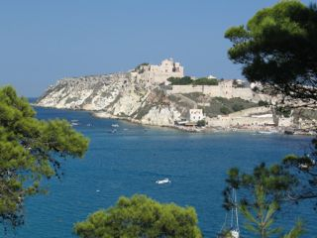 | BURANO  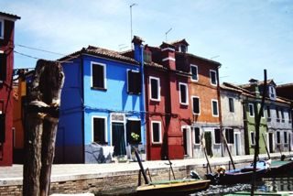
ASINARA  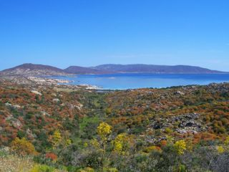 | CAPRERA  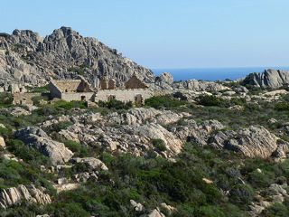
LAMPEDUSA  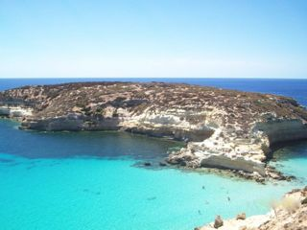 | USTICA  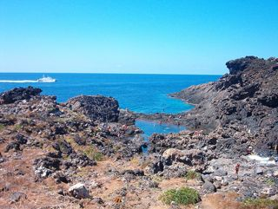
PANTELLERIA  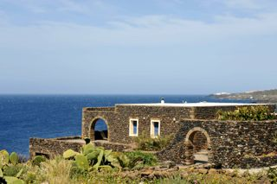 | GIGLIO  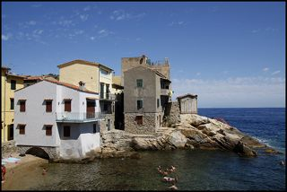
LIPARI  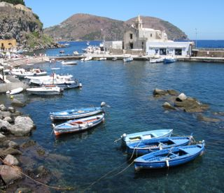 | ELBA  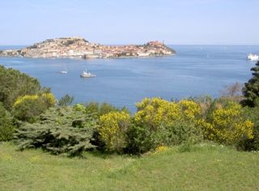
STROMBOLI  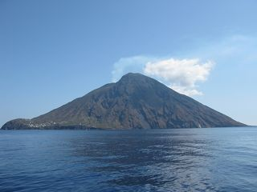 | ISCHIA  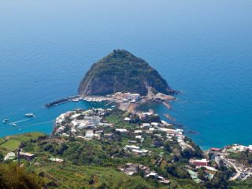
VULCANO  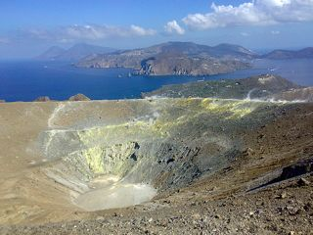 | ISOLE PONTINE  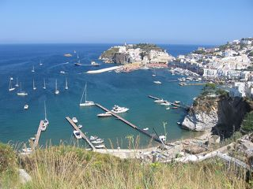
ISOLE EGADI  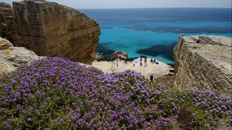 | SICILIA  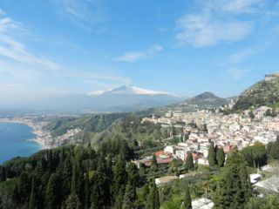
SARDEGNA  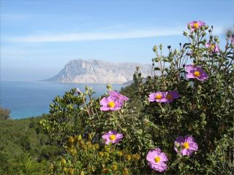 | LIDO DI VENEZIA  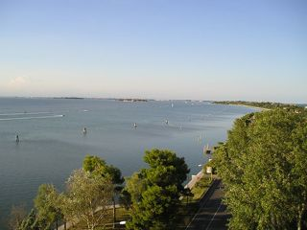
PROCIDA  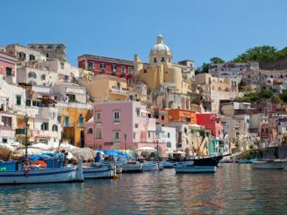 | MONTECRISTO  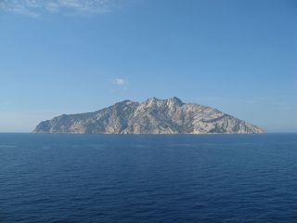
GORGONA  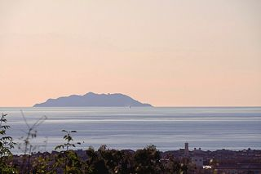 | LINOSA  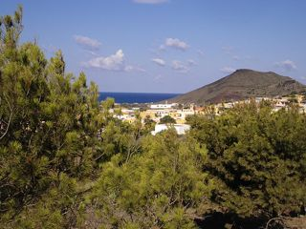

Urheberrechte an den Fotos:

Die Bilder aus der Bildergalerie wurden von den Inhabern der Urheberrechte dem Landesbildungsserver freundlicherweise zur Nutzung zur Verfügung gestellt.

Asinara
trinchetto
http://www.flickr.com/photos/8810882@N03/2757178832
CC BY-NC-ND 2.0

Burano

Lorenz Manthey

Bildergalerie

Caprera

Wuppataler

http://www.flickr.com/photos/29214188@N05/8082929752/sizes/m/in/photostream/

CC BY-NC-SA 2.0

Capri

Lorenz Manthey

Bildergalerie

Egadi

boboviel

http://www.flickr.com/photos/27683973@N08/5887937780/sizes/m/in/photostream/

CC BY 2.0

Elba

Lisa Frank

Bildergalerie

Giglio

Luca Laz

http://www.flickr.com/photos/lucalaz/2658442540/sizes/m/in/photostream/

CC BY-NC 2.0

Gorgona

adriana p. 蠍/44Livorno

http://www.flickr.com/photos/adrip/4008854809/sizes/m/in/photostream/

CC BY-NC-SA 2.0

Ischia

Norbert Manthey

Bildergalerie

Isola Bella

darkensiva

http://www.flickr.com/photos/darkensiva/2136620486/

CC BY 2.0

Isole Pontine

Nino_it

http://www.flickr.com/photos/nino_it/2445438957/sizes/m/in/photostream/

CC BY-NC 2.0

Lampedusa

Rapazza

http://raypazza.deviantart.com/art/Lampedusa-183711910

Creative Commons Attribution-Noncommercial-No Derivative Works 3.0 License.

Lido di Venezia

pandemia

http://www.flickr.com/photos/pandemia/537622/sizes/m/in/photostream/

CC BY 2.0

Linosa

illinosaro1960

http://www.flickr.com/photos/illinosaro1960/2919557867/sizes/m/in/photostream/

CC BY-NC-SA 2.0

Lipari

flrnt

http://www.flickr.com/photos/14732738@N00/2793429910CC BY-SA 2.0

Montecristo

Ondablv

http://www.flickr.com/photos/ondablv/2074620854/sizes/m/in/photostream/

CC BY-NC 2.0
Pantelleria
murmanskbear
http://murmanskbear.deviantart.com/art/Typical-Pantelleria-s-view-161019872
CC BY-NC-ND 3.0

Procida

Norbert Manthey

Bildergalerie

Sardegna

Alexandra Sagert

Bildergalerie

Sicilia

Lars Optehostert

Bildergalerie
Stromboli
flrnt
http://www.flickr.com/photos/flrnt/2793004773/sizes/m/in/photostream/
CC BY-SA 2.0

Ustica

goldmund100

http://www.flickr.com/photos/luca_volpi/362752218/sizes/m/in/photostream/

CC BY-SA 2.0
Vulcano
daturi
http://www.flickr.com/photos/davideturi/2797192675/sizes/m/in/photostream/
CC BY-NC-SA 2.0

