Grammar / The simple present / exercises
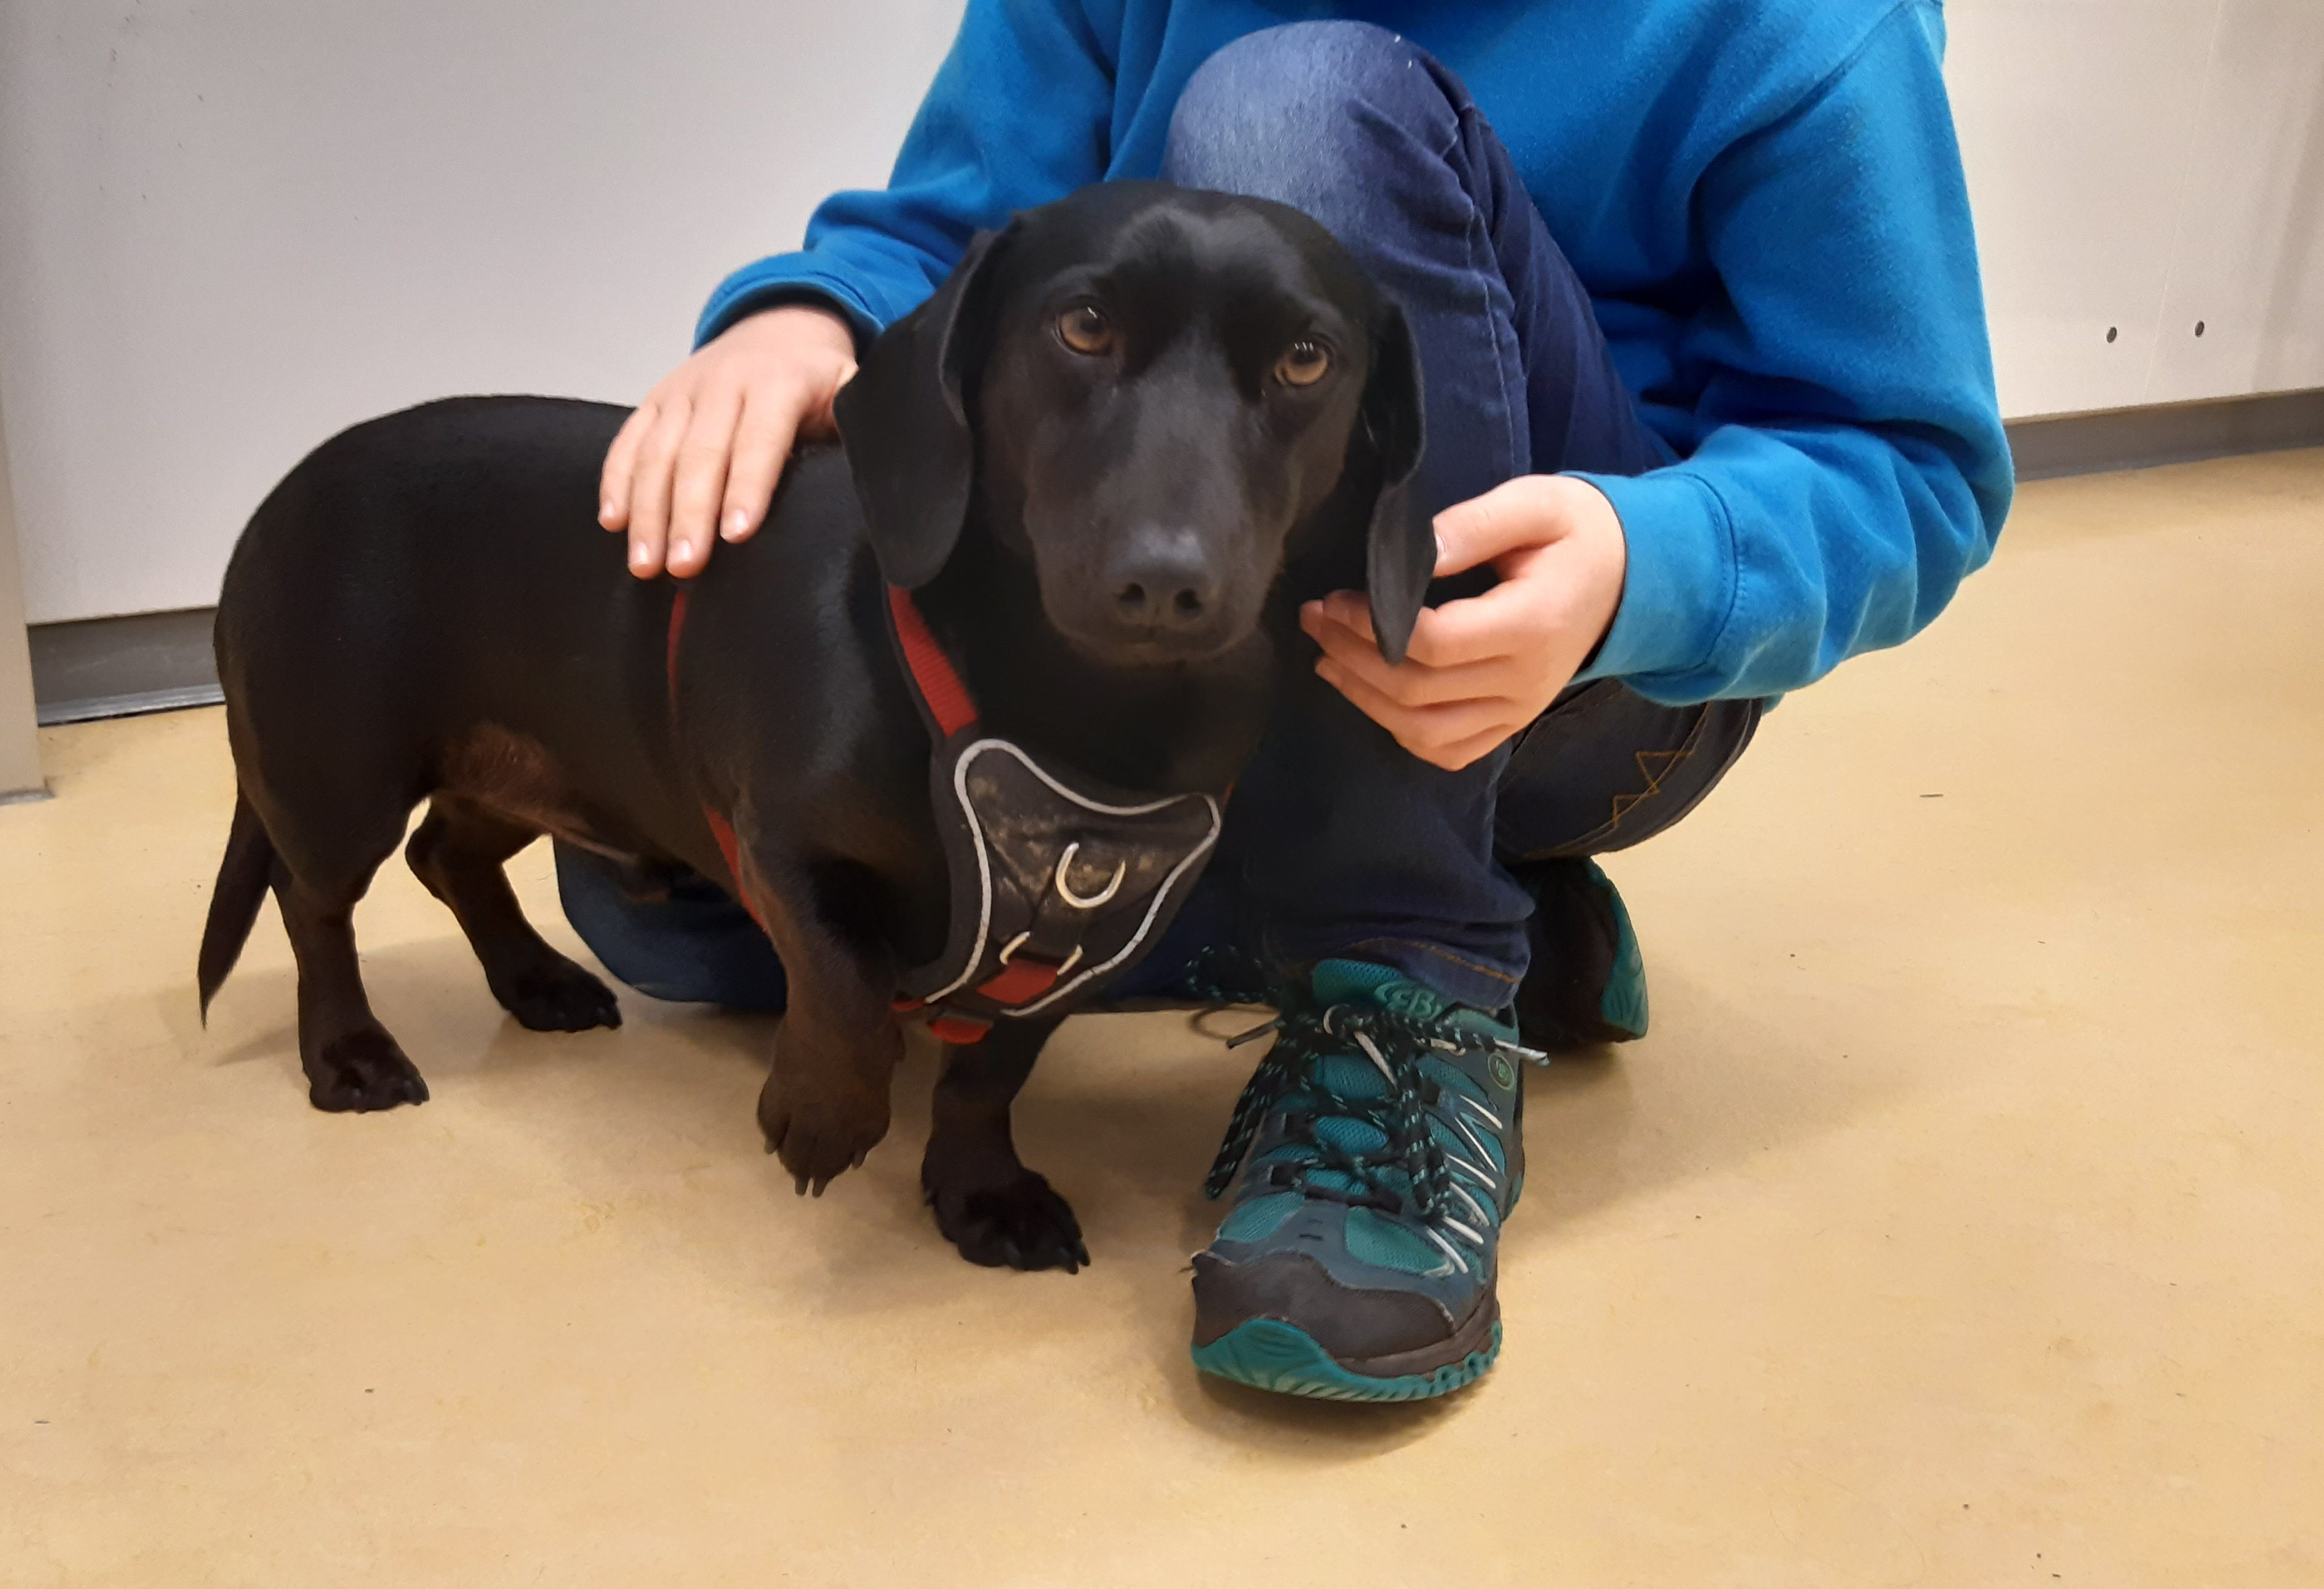
- What dogs do and don’t do
- Are these sentences right or wrong ?
- Correct the wrong statements
(= verbessere die falschen Sätze.)
- Dogs eat pizza for breakfast.
Dogs don’t eat pizza for breakfast, they eat dog food.

- Dogs like long walks in the park.
- Dogs play computer games.
- Winston works at a school.
- Winston teaches English to his students.
- Winston always barks at his students.
He, she, it,
das -s muss mit!

- A day in the life of a school dog
- Please fill the gaps with the correct forms of the verb
– use the simple present!
Winston is a school dog. He ____________ (to work) at a big school. He _____________ (not + to teach) the students, but he _____________ (to help) them a lot. His friend, Mr Goodwill, ______________ (to be) a teacher and Winston ________________ (to help) him, too. He _____________ (to wake) him up every morning and he ______________ (to bark) at him when he _____________ (to be) late – not late for school, but late for his breakfast. “I ________________ (to need) a good breakfast before school __________________ (to start). I _________________ (to like) dog food and a bit of fruit for breakfast, but I___________________ (not + to like) muesli. I _______________ (not + to know) why Mr Goodwill ________________ (to like) muesli. That is food for birds. Oh well, he _____________ (to be) a Music teacher, too. Maybe he ________________ (to eat) muesli to sing like a bird – woof woof!?
We both ___________________ (to like) cheese a lot, but I ________________ (not + to get) cheese very often. Luckily I _________________ (to know) where the cheese is and when Mr Goodwill ______________ (to do) his homework, I __________ (to do) my work, too …
I _____________ (to help) in the kitchen and __________________ (to clean) the fridge and _____________(to eat) all the smelly cheese. I __________ (to like) a clean kitchen ”.

(to) teach = unterrichten / beibringen
luckily = glücklicherweise
fridge = Kühlschrank

