Grammar / The present progressive
Normally, Mr Goodwill and I get up early. Then we always have breakfast together and go to work. We both work at school. But today is different, look at these photos:
We are enjoying the sun! Look! I am sunbathing now and Mr Goodwill is taking photos.
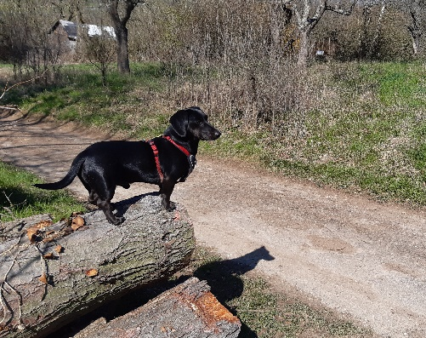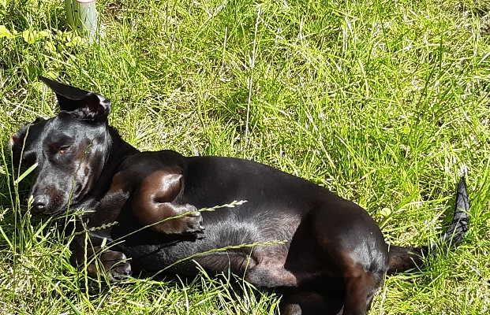
I am not working at school today, Mr Goodwill and I, we are going for a long walk.

Hier im Text kannst du schon einige Verbformen im present progressive (= die Verlaufsform der Gegenwart) entdecken – sie sind fett gedruckt. Mit der Verlaufsform drückst du aus, was gerade im Moment passiert oder was gerade im Verlauf ist.
Die folgende Tabelle zeigt dir, wie du die Formen bildest und auf was du achten musst.
Bejahte Aussagesätze | Verneinte Aussagesätze
I am sunbathing.  Mr Goodwill is taking photos.  We are going for a long walk. | I’m not / I am not working today.  Mr Goodwill is not / isn’t working today.  We are not / We aren’t working today.
am / is / are + infinitive + -ing | am not / is not / are not + infinitive + -ing
Watch out:
- Endet der Infinitiv auf -e z.B. (to) take, so fällt bei der Bildung der Verlaufsform das stumme -e weg: (to) take am / is / are taking

- Nach einem einzelnen, betonten Vokal wir der Konsonant verdoppelt: (to) run am / is / are running / (to) stop am / is / are stopping

- Write the -ing forms:

(to) call calling
(to) wait waiting
(to) have having
What is Winston doing in this picture?
He is looking into the water. / He is drinking water.
(to) drink drinking
(to) look looking
- Today is different – please complete the sentences. Use the present progessive.

Every Friday, Mr Goodwill and Winston go for a long walk… | (to) work / garden / now  …but not today. They are working in the garden now.
Normally, Winston helps Mr Goodwill in the garden… | (to) chase / mice / at the moment  …but not today. Winston is chasing mice at the moment.
Mr Goodwill often talks to his neighbour, Mrs Merrygold… | (to) sing / football songs / now  …but not today. Mr Goodwill is singing football songs now.
Winston doesn’t usually like football songs, …. | (to) bark  ... but not today. Today, Winston is barking happily, because his favourite football team won a match.
In the evening, Winston and Mr Goodwill often eat dinner at home, … | (to) visit Mrs Merrygold  …but not today. They are visiting Mrs Merrygold.
Normally, they watch TV together, … | (to) tell / funny stories, (to) laugh  …but not today. Mr Goodwill is telling funny stories now and Mrs  Merrygold is laughing loudly at the moment.
Winston always enjoys these quiet evenings with Mr Goodwill, … | (to) feed / (to) not pay attention (= nicht aufpassen)  …but today is different and Winston likes it at Mrs Merrygold’s house, because she is feeding him a lot of cheese and Mr Goodwill isn’t paying attention.  Woof, woof - what a great Friday!

Grammar File: SIMPLE PRESENT and PRESENT PROGRESSIVE
- Please read the following sentences and underline (= unterstreiche) the sentences and questions in the simple present in GREEN and underline the sentences and questions in the present progressive in RED.

Every Friday, Winston and Mr Goodwill go for a long walk. Does Winston like cats?
Look, Winston is chasing a cat. Winston, are you still chasing Mrs Merrygold’s cat? Mr Goodwell doesn’t like cats. What does Mr Goodwill do every Friday?
Winston isn’t sleeping, he is playing with a cat at the moment.
Winston always looks for cats. Winston, where are you going? Stop!
Oh no, Mrs Merrygold’s cat is coming back now.

THE SIMPLE PRESENT | THE PRESENT PROGRESSIVE
positive Aussagesätze  Bei Aussagesätzen im simple present darfst du das “s” in der 3. Person Singular (he, she, it) nicht vergessen.  Bsp.: Winstons always looks for cats. | positive Aussagesätze  Aussagesätze im present progressive werden mit am / is / are und der  - ing Form gebildet.  Bsp.: Winston is chasing a cat.
negative Aussagesätze  Negative Sätze werden mit  don’t  doesn’t + Infinitiv gebildet.  Bsp.: Mr Goodwill doesn’t like cats. | negative Aussagesätze  Negative Sätze werden mit  am + not  is + not Infinitiv + -ing gebildet.  are + not  Bsp.: Winston isn’t sleeping.
? Fragen werden mit  Do  Does + Infinitiv gebildet.  Bsp.: Does Winston like cats? | ? Fragen werden mit  am  is + Infinitiv + -ing gebildet.  are  Bsp.: Are you still chasing Mrs Merrygold’s cat?
Gebrauch:  Du brauchst das simple present, um über Dinge zu sprechen, die man regelmäßig macht. Signalwörter wie often, usually, every day, every Saturday, etc. zeigen dir, dass du die einfache Form der Gegenwart (=simple present) verwenden musst. | Gebrauch:  Du brauchst das present progressive, um über Dinge zu sprechen, die gerade im Moment geschehen. Signalwörter wie now, at the moment zeigen dir, dass du die Verlaufsform (=present progressive) verwenden musst.

