The position of adverbs – Exercises IV
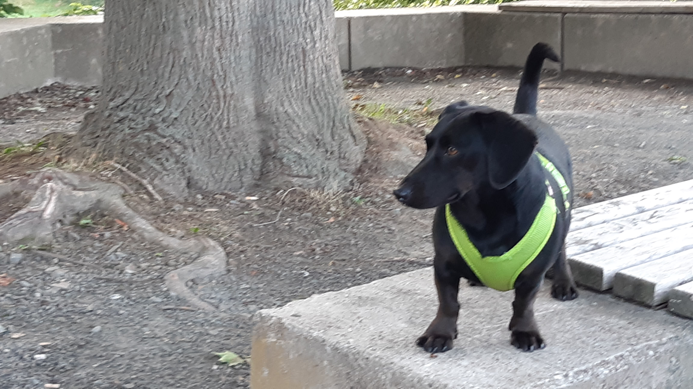
Adverbs of frequency, of manner and adverbs of place and time
Remember:
MANNER before PLACE before TIME.

Fill in the adverbs
(appearance in brackets: in alphabetical order).

Winston and Mr. Goodwill on their way to school
- Before Mr. Goodwill goes to school …................................., Winston is …................ …........................................... . He likes the students and waits for the lessons …............................ .
(at the front door; eagerly; in the mornings; often)
- Mr. Goodwill's bag ….............. lies …................................ …................................. . He …............................. packs his school bag ….......................... .
(always; at the door; carefully; from Monday to Friday; usually)
- He …......................... does that job …................................, so everything is prepared for the school day.
(on Sunday evening; usually)
- When they are ready, Winston follows Mr. Goodwill …....................... …......................................... , because Mr. Goodwill rides his bike to school …............................................ .
(every weekday; happily; to the bike shed)
- Winston ….......................... comes along except for Wednesdays, when he is …............................................... …......................................... .
(always; at dog school; from 9 to 11 am)
- Winston can follow Mr. Goodwill …..................... ….........................., because he can run …...................................... . They both enjoy their ride because of the fresh air, which makes them ready for the day. And so the day can start!
(easily; quickly; to school)

bike shed: Fahrradschuppen

